Renaissance Artworks
Students Name:
Institution Affiliation:

Renaissance Artworks
The Virgin with the Infant Saint John the Baptist adoring the Christ Child accompanied by an Angle (“The Virgin of the Rocks”) is an artwork in The National Gallery made by an artist known as Leonardo da Vinci in the period about 1491/2-9 and 1506-8. Oil on poplar, thinned and cradled is the medium and support of the artwork with 189.5×120 cm as its dimensions. The artwork is located in Room 66 and was bought in 1880 (The National Gallery, n.d.).
The artwork was commissioned by the Milanese Confraternity of Immaculate Conception for their oratory in San Francesco in 1480. “The Virgin of the Rocks” artwork seems not precisely to be describing the mystery of the Immaculate Conception. The artist might have painted the artwork in his Florence where legends concerning the young Saint John the Baptist were famous (Vein, & Mouret, 2018).
Leonardo da Vinci (the artist) was a painter, inventor, architect and also a student of all things scientific. He was even portrayed as the renaissance man due to his natural genius which crosses so many disciplines. Leonardo da Vinci is remembered for his influence on the intellectual development of Europe during the Renaissance period and even beyond the period. Apart from being a talented artist, Leonardo da Vinci helped in the invention of different things such as helicopters parachute tanks and many more (Vein, & Mouret, 2018).
In my opinion, Leonardo da Vinci artwork message could be love, care, and support. The painting of the Virgin and infant St. John the Baptist adoring the Christ Child show an aspect of love to each other. The company of the Angle implies support. Leonardo da Vinci tries to encourage us always to support each other to show instances of love to each other. The piece supports the religion in the society. It helps people understand the mystery of the Immaculate Conception that challenges many people.
Bacchius and Ariadne is an artwork by Titian in The National Gallery which was made in 1520-3. Oil on Canvas is the support and medium of the artwork with 176.5 × 191 cm dimensions. The artwork is located in Room 6 in the national gallery and was bought in 1826. Alfonso d'Este commissioned the artwork, Duke of Ferrara, as a more significant part of a decorative scheme for a small room in the ducal palace (The National Gallery, n.d.).
The god of wine, Bacchus precisely emerges with his followers from the landscape to the right. He leaps down from the chariot after on sights fall in love with Ariadne. Tea ship shown from a distance belongs to Theseus who had abandoned Ariadne on the Greek Island of Naxos. The start above her head represents how she was turned into a constellation after being raised to heaven by Bacchus. However, there is a clear depiction of the fear that she had to Bacchus (Cole, 2018).
Bacchius and Ariadne painting are one of the most famous series by Bellini, Titian, and the Ferrarese artist Dosso Dossi. Bacchius and Ariadne were, in fact, the better substitute for another painting from Raphael of a similar subject that Duke had commissioned.
Titian’s close friendship with writer Pietro Aretino made him get some pot his commissions. The friendship is an implication to the society that a friend who does something different from what one does can be of great importance. Titan has inspired a large generation of artists. The artwork depicts how love makes fear fade away from people. The piece has the historical representation of gods.
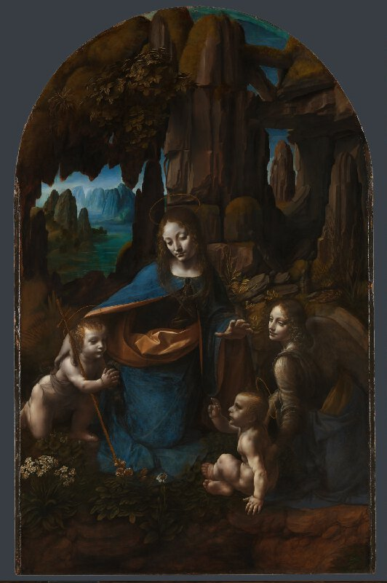
The Virgin of the Rocks
about 1491/2-9 and 1506-8, Leonardo da Vinci
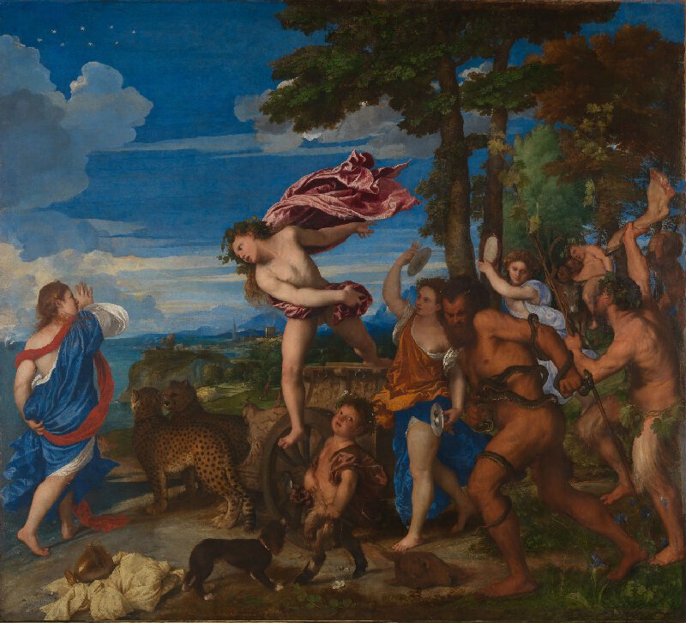
Bacchus and Ariadne
1520-3, Titian
References
Cole, B. (2018). The Renaissance Artist at Work: From Pisano to Titian. Routledge.
The National Gallery, London. (n.d.). Leonardo da Vinci | The Virgin of the Rocks | NG1093 | National Gallery, London. Retrieved from https://www.nationalgallery.org.uk/paintings/leonardo-da-vinci-the-virgin-of-the-rocks
The National Gallery, London. (n.d.). Titian | Bacchus and Ariadne | NG35 | National Gallery, London. Retrieved from https://www.nationalgallery.org.uk/paintings/titian-bacchus-and-ariadne
Vein, A. A., & Mouret, A. (2018). Claw hand in a Renaissance portrait. The Lancet Neurology, 17(9), 742.

